**ROBOTIC PROCESS AUTOMATION**

**OF LOAN PROCESSING**

**A MINI PROJECT-II REPORT**

***Submitted by***

**CHENNAKESAVAN RB. (1605013)**

**GOKUL V. (1605026)**

**NAVEEN KUMAR C. (1605049)**

***in partial fulfillment for the award of the degree***

***of***

**BACHELOR OF TECHNOLOGY**

***in***

**INFORMATION TECHNOLOGY**

**SRI RAMAKRISHNA ENGINEERING COLLEGE**

[Educational Service: SNR Sons Charitable Trust]

[Autonomous Institution, Accredited by NAAC with ‘A’ Grade]

[Approved by AICTE and Permanently Affiliated to Anna University, Chennai]

[ISO 9001:2015 Certified and All Eligible Programmes Accredited by NBA]

Vattamalaipalayam, N.G.G.O. Colony Post,

**COIMBATORE – 641 022**

**ANNA UNIVERSITY : CHENNAI 600 025**

**MAY 2019**

**ANNA UNIVERSITY : CHENNAI 600 025**

**BONAFIDE CERTIFICATE**

**16IT259 – Mini-Project-2**

Certified that this Mini Project - II Report **“Robotic Process Automation of Loan Processing”** is the bonafide work of **“Chennakesavan RB., Gokul V., Naveen Kumar C.”** who carried out the project under my supervision.

**SIGNATURE SIGNATURE**

Dr.M.Senthamilselvi Dr.Preethi Harris,

**HEAD OF THE DEPARTMENT SUPERVISOR**

Professor, Assistant Professor(Sr.Gr),

Information Technology, Information Technology,

Sri Ramakrishna Engineering College, Sri Ramakrishna Engineering College,

Coimbatore-641022. Coimbatore-641022.

**Submitted for the Mini Project Viva-Voce Presentation held on ____________**

**INTERNAL EXAMINER EXTERNAL EXAMINER**

**ACKNOWLEDGEMENT**

We put forth our hearts and souls to thank the almighty for being with us through our achievements and success. We would like to express our unfathomable thanks to our esteemed and Honorable **Managing Trustee** **Thiru. R.Vijayakumhar** and **Joint Managing Trustee,** **Thiru. D.Lakshmi Narayananasamy** for giving us the chance to be a part of this elite team at Sri Ramakrishna Engineering College, Coimbatore.

We convey our deepest gratitude and thanks to our **Director** (Academics) **Dr.A.Ebenezer Jeyakumar,** SNR Sons Charitable Trust, and Coimbatore for giving us the opportunity to do this project.

We would like to express our sincere thanks to our honorable **Principal**  **Dr. N.R.Alamelu,** for the facilities provided to complete this project.

We take the privilege to thank the **Head of the Department**, **Dr.M.Senthamilselvi,** for her consistent support and encouragement at every step of our project work.

We wish to convey our special thanks to our academic co-ordinator and miniproject co-ordinator, **Dr. Preethi Harris, Associate Professor**, Information technology for her consistent support, timely help and valuable suggestions during the entire period of our project work.

We would like to express our sincere thanks to our course instructor, **Dr. Preethi Harris, Associate Professor** for his valuable support in the completion of this project.

We extend our sincere gratitude to all the teaching and non-teaching staff of our department who helped us during our project.

**ABSTRACT**

Bank Loan Processing in Automation is application for calculating credit score and find the suitable to offer them loan. In this project tried to show the credit score calculation and working for the loan process. RPA which daily activities and one such application is loan approval. In this Work we have automated loan approval process by scrapping the details from customer submitted document in the website we have created. Then, the credit score determines the loan eligibility. This Information is sent as e-mail notification to the customer. The Experimentation reveals that the entire loan approval process when automated takes 10-15 minutes. The notification sent to customer as Pdf document.

**TABLE OF CONTENTS**

|  |  |  |
| --- | --- | --- |
| **Chapter No.** | **Title** | **Page No.** |
|  | **ABSTRACT** | iii |
| **1** | **INTRODUCTION** | 1 |
| **2** | **LITERATURE SURVEY** | 6 |
| **3** | **DESCRIPTION** |  |
|  | 3.1 INTRODUCTION | 8 |
|  | 3.2 BLOCK DIAGRAM | 10 |
|  | 3.3 WORKING PRINCIPLE | 10 |
| **4** | **RESULTS** | 14 |
| **5** | **CONCLUSION** | 17 |
| **6** | **REFERENCES** | 18 |

**CHAPTER 1**

**INTRODUCTION**

* 1. **Robotic Process Automation:**

Robotic Process Automation is the technology that allows anyone today to configure computer software or a robot to emulate and integrate the actions of a human interacting within digital systems to execute a business process. RPA robots utilize the user interface to capture data and manipulate applications just like humans do. They interpret, trigger responses and communicate with other systems in order to perform on a vast variety of repetitive tasks. Only substantially better an RPA software robot never sleeps, makes zero mistakes and costs a lot less than an employee.

**1.2 UiPath Studio**



**Figure 1.2.1 UiPath Studio**

Automation excellence requires a tool that can model all your organization’s business processes, regardless of complexity and scale. UiPath Studio, our powerful and user-friendly automation canvas, is an essential component in the UiPath

platform. UiPath Studio features a rich collection of pre-built activities, integrates with several programming languages, and promotes ease-of-use, scalability, and efficiency.

**Acceleration in UiPath:**

Create automations with our drag and drop, code-free, studio editor. Leverage our library of hundreds of activities and pre-built automation components. For fast and easy troubleshooting our visual debugger highlights an exact error and displays easy to comprehend messages.

No more manual, error-prone programming of each process step and user action, Studio has specialized recorders that record your actions and build them into an automation workflow. Studio offers four types of recorders: basic, desktop, web, and Citrix.

No need to invent the wheel. Share and reuse ready-made automation components from Studio’s extensible libraries and save on development time and cost. Build reusable components with Studio to collaborate, standardize, and work on automation best practices within your organization and with fellow RPA developers for the most effective results.

**Key features:**

**Cognitive enhancements:**

Embedded cognitive and OCR technologies from ABBYY, Stanford NLP, IBM Watson, Google, Microsoft and any machine learning libraries via Python code activities.

**Workflow recorders:**

Specialized workflow recorders for desktop apps, web apps, Citrix environment, and terminal emulators. Simplifies training, makes process modeling and automation faster, and more precise.

**Universal Search:**

Unified search and find across all the automation resources like libraries, activities, projects and open workflows contained within a UiPath Studio process. This significantly accelerates the automation and maintenance of the development process.

**Custom workflows:**

RPA developers can design powerful and complex automations by incorporating custom VB.Net, Python, Auto hotkey, Javascript, Powershell, and JAVA code directly into an automation workflow. Their work can be stored in the Studio library and shared with other team members across current and future projects.

**Localization:**

Get the native feel of Studio and conveniently design workflows in your preferred local language. UiPath Studio is now available in Japanese. French, German and Russian to follow soon.

**Documenting rules:**

Workflow engine visually documents business process rules. Easier and more accurate knowledge transfer and error checking.

**Debugging:**

Analyze your automated processes using visual, step-by-step process execution, breakpoints and highlighting of target elements. A global exception handler simplifies debugging and catches unexpected errors.

**Collaborative automation:**

It can Share, reuse automation components and collaborate with other team members in your organization using the extensible library. Collaborate and standardize process across the organization as Studio is directly integrated with TFS, VSTS and SVN source control systems.

**Extensible architecture:**

You can develop your own reusable custom activity or shareable automation component in your preferred programming language.

* 1. **Orchestrator:**

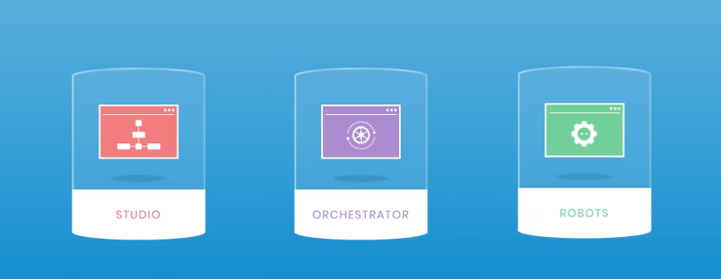

**Fig 1.3.1 UiPath Orchestrator**

Imagine thousands of Robots at work. They’re running tens of thousands of automated processes. With UiPath Orchestrator in command, your entire virtual workforce is controlled, managed and monitored securely in one place.

**Deploy anywhere:**

In the cloud or on-premises, physical or virtual machines, it’s easy to start small and scale fast.

**Scale optimally:**

Priorities and workloads change. Orchestrator groups Robots in queues and keeps them busy with prioritized work.

**Secure digital workforce:**

Securely store Robot credentials and limit access to specific roles and responsibilities with CyberArk Enterprise Password Vault. Improve your security posture with SAML 2.0 single sign-on access to Orchestrator using your standard organizational credentials. Smartcards are used to provide enhanced security and to reduce risk of data breach. Orchestrator support for smartcards ensure unattended Robots can operate with the same high security.

**Audit everything, improve as you go:**

All Robot and user activities can be recorded in Orchestrator supporting all your audit and compliance needs. You can gain insights into performance, with powerful visual analytics in real time.

**1.4 Software Robots**

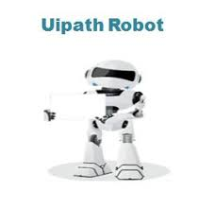

**Fig 1.4.1 UiPath Robots**

UiPath Robots are a fundamental component of the UiPath Enterprise RPA Platform. Robots execute the automation workflow designed in UiPath Studio andcan be centrally managed from UiPath Orchestrator. To cater to diverse automation scenarios, UiPath offers both Attended and Unattended Robots.

**CHAPTER 2**

**LITERATURE SURVEY**

**2.1 Loan Management in Albanian Bank**

Bank loan management is crucial and it is instrumental in ensuring the success or failure of any credit institution. Albanian banking system as a relatively newcomer in the market economy, started to apply modern lending rules & procedures after the major loan portfolio was already created, whereas the key role of risk management and its respective procedures was mostly unknown for the majority of banks in Albania, during the credit boom. On the other side, Bank of Albania has been relatively late in taking up its role in controlling and monitoring the process of setting up the lending structure and regulation, as a mandatory standard, applicable in lending practices for commercial banks in Albania. The adjusted Basel I standards helped banks to weather the effects of the last financial crisis, but proved incomplete, in terms of ensuring long - term loan quality management. The paper shed light on main reasons why Albanian banks lagged behind in terms of applying and implementing modern risk management practices and procedures, during the credit boom period and explain why applying rules, procedures, intending to correct mistakes done during lending process, proved to be costly and of less success. Finally, the paper provides some recommendations on improving internal lending practices and procedures, along with modern risk management principles and near-future full implementation of Basel II standards by Bank of Albania.

**2.2 Credit Score – Loan Approval**

Ethical banking, microfinance institutions or certain credit cooperatives, among others, grant socially responsible loans. This paper presents a credit score system for them. The model evaluates both social and financial aspects of the borrower. The financial aspects are evaluated under the conventional banking framework, by analysing accounting statements and financial projections. The social aspects try to quantify the loan impact on the achievement of Millennium Development Goals such as employment, education, environment, health or community impact. The social credit score model should incorporate the lender’s know-how and should also be coherent with its mission. This is done by using the Analytic Hierarchy Process (AHP) technique. The paper illustrates a real case: a loan application by a social enterprise presented to a socially responsible lender. The decision support system not only produces a score, but also reveals strengths and weaknesses of the application.

**CHAPTER 3**

**PROJECT DESCRIPTION**

**3.1 INTRODUCTION**

Credit scoring is the set of decision models and underlying techniques that aid lenders in the granting of consumer credit. These techniques determine who will get credit, how much credit they should get, and what operational strategies will enhance the profitability of borrowers to the lenders. Further they help to assess the risk in lending. Credit score is dependable assessment of a person’s credit worthiness since it is based on actual data. A lender commonly makes two types of decision: first whether to grant credit to a new applicant, and second how to deal with existing applicant, including whether to increase their credit limits. In both cases, whatever the techniques used, it is critical that there is a large sample of previous customers with their application details, behavioral patterns, and subsequent credit history available. Most of the techniques use this sample to identify the connection between the characteristics of the consumers(annual income, age, number of years in employment with their current employer, etc..)and their subsequent history. Typical application areas in the consumer market include: credit cards, auto loans, home mortgages, home equity loans, mail catalog orders, and a wide variety of personal loan products. Robot Process Automation in loan processing is explained in the fig:3.1.

**Flowchart:**

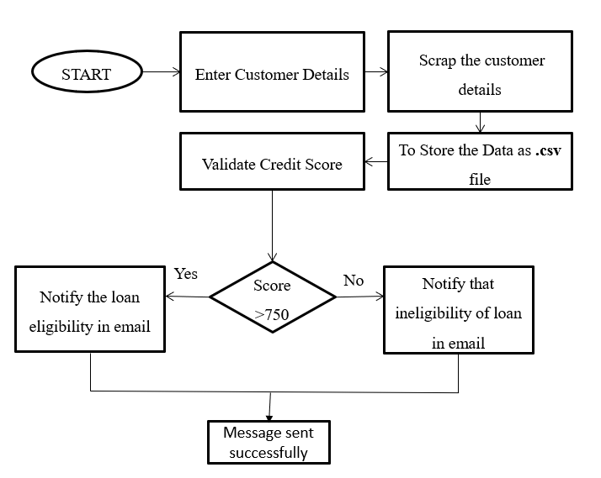

**Fig:3.1 Loan Eligibility**

**3.2 BLOCK DIAGRAM**

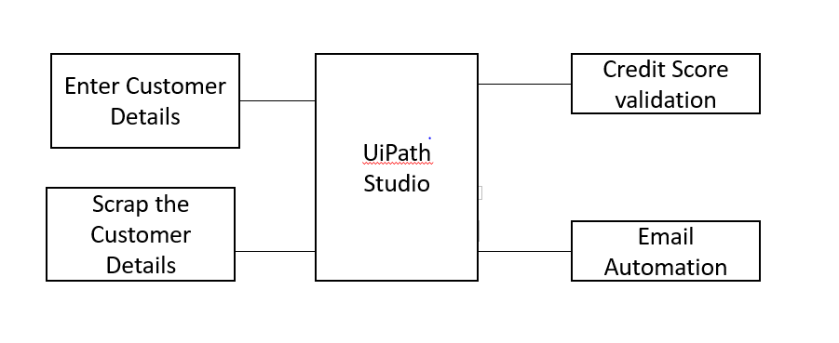

**Figure 3.2.1 Workflow Scrapping**

The modules used in the proposed system are:

* Get the customer details
* Calculate credit score
* Eligibility checking for loan
* Email notification

**3.3 WORKING PRINCIPLE**

The Detailed working of proposed system is represented in fig3.2.1.

**Get the Customer Details**

Create a web page to get details from the user and verify the each and every login id and then allowed to enter details. Then, they can login using verified id and continue to form filling page. The page contains personal details of a person like mobile number, Aadhaar number, pan card, income, loan type, bank details. Scrap the customer details from the web page using UiPath studio. The scrapped details should be saved as .csv file. The csv file is used to calculate the credit score of a person.

**Calculate credit score**

Credit score can be calculated based on the type of loan. Scores based on data from credit reports. Separate credit score for each of the three credit bureaus

Higher is better For valid score, the credit report must have: At least one account opened for six months or more, and At least one account that has been reported to the credit bureau within the past six months, and No indication of deceased on the credit report

Credit scores based on these 5 categories:

* 35% Payment History
* 30% Total Debt
* 15% Length of Credit History
* 10% Credit Mix
* 10% New Credit

**Payment History**

Paying on time one of the most important factors. Overall good credit more important than missing one or two payments. Payment history includes: credit cards, retail accounts, installment loans and mortgage loans. Negative factors: bankruptcies, foreclosures, lawsuits, wage attachments, liens, and judgements. Late or missed payments: how late, how much owed, how recent, and how many.

**Total Dept**

Amount owed on all accounts. Amount owed on different types of accounts

Credit utilization on revolving accounts (how much of your available credit you are using)

* + High percentage- negative impacts
  + Low percentage- positive impacts- in some cases, better than not using any of your available credit

Someone who is close to "maxing out" several credit cards has a high credit utilization ratio and may have trouble making payments in the future.

**Length of Credit History**

Longer credit history will increase score BUT new users will not necessarily be negatively impacted. Age of oldest account. Age of newest account. Average age of all accounts. Use of certain accounts.

**Credit Mix**

Mix of credit cards, retail accounts, installment loans, finance company accounts, and mortgage loans will be considered. Has your credit experience been only one type? Don’t open accounts you won’t use. Can raise credit score by having credit cards and installment loans with a good payment history.

**New Credit**

Don’t open a lot of new accounts quickly. Opening several new accounts in short amount of time represents risk. How many recent inquiries there are (when a lender makes a request for your credit report or score) Inquiries are on your report for 2 years but only impact your FICO score for 12 months.

**Eligibility checking for loan**

CREDIT is a three digit number which is calculated on the basis of the financial history of the applicant. The CREDIT Score ranges between 300 to 900 and people having higher score have better chances of getting loans approved. As per CREDIT’s own analysis, 79% of the loans approved are for those individuals who have a score of 750 or more.

**Email Notification**

From an RPA perspective, two situations for email interactions have been identified:

Input of a Process

* Names and IDs coming in subject or body
* Input files coming as attachments (.xmls, .pdf)
* Output of a Process
* Progress reports to managers
* Exception alerts

The UiPath.Mail.Activities package includes all the activities related to e-mails. They enable you to send emails via the SMTP protocol, or read them via the POP3 one. The Internet Message Access Protocol (IMAP) can be used for receiving e-mails, marking them as read or moving them between folders. Microsoft’s enterprise email solution, Exchange, is fully integrated in Studio. Therefore, activities for sending, receiving, moving emails between folders and deleting them are featured. Outlook activities are easier to configure and do not require you to set up servers, users or other details, as they work with the API of the desktop application and with already existing Outlook accounts. The most generic email activities enable you to save messages as .eml files and mail attachments to the local drive.

**CHAPTER 4**

**4. RESULTS**

**4.1 RESULTS**

The proposed system for obtain the customer details from web page using data scrapping tool using UiPath studio. The customer details stored as .csv file. Then credit score will be calculated using the above customer details. The credit score must greater than 750 or else the person is not eligible for loan. If the credit score is calculated, email notification is send to the customer whether he is eligible or not and about credit score details.

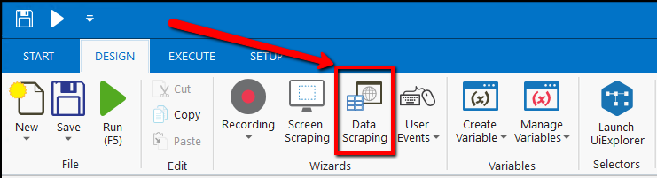

**Figure 4.1 – Data Scrapping**

Scrapped Data is stored in .csv file and it comprises of headers and valid customer details are represented in fig : 4.2 .

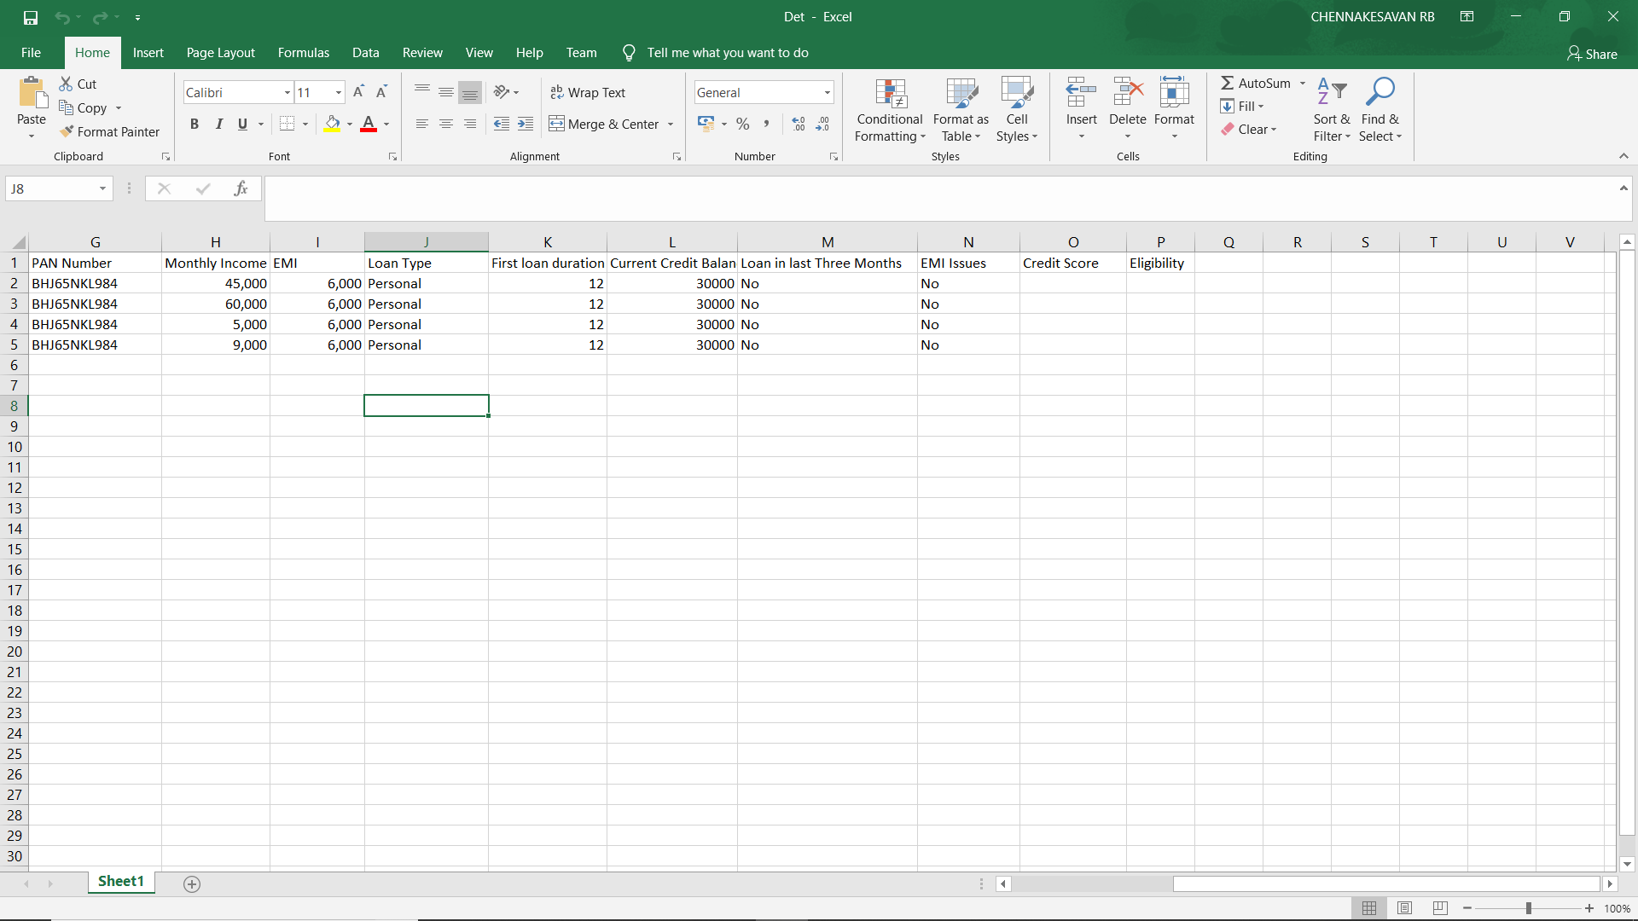

**Fig 4.2 - .csv file**

The Work flow can be written for the calculation of credit score and detection of eligibility.

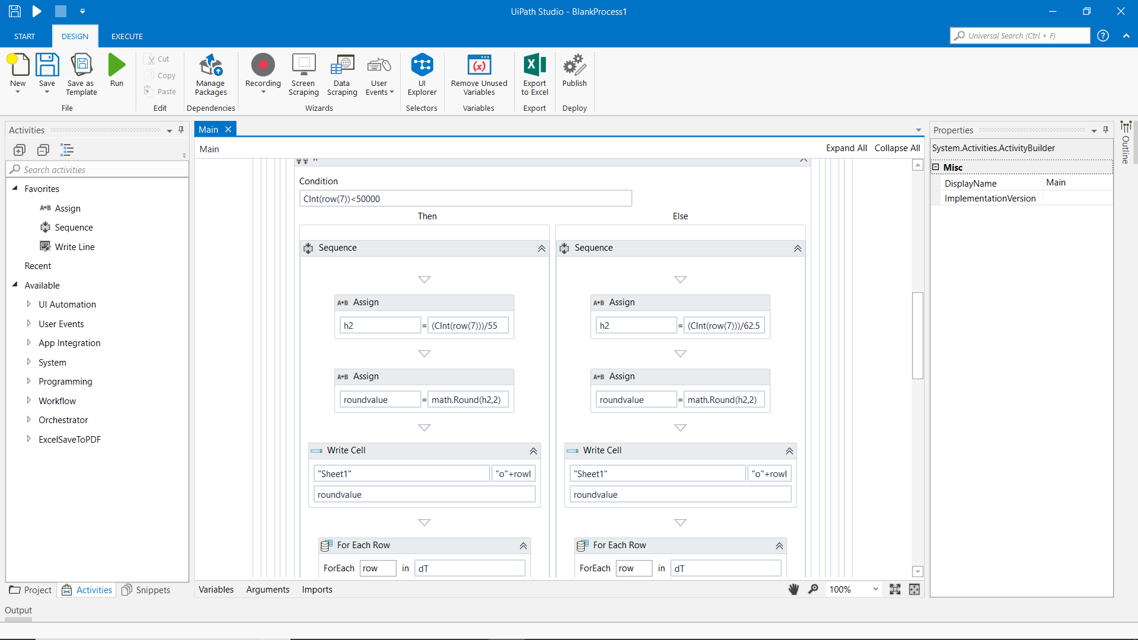

**Fig 4.3 Computation writer using the work flow**

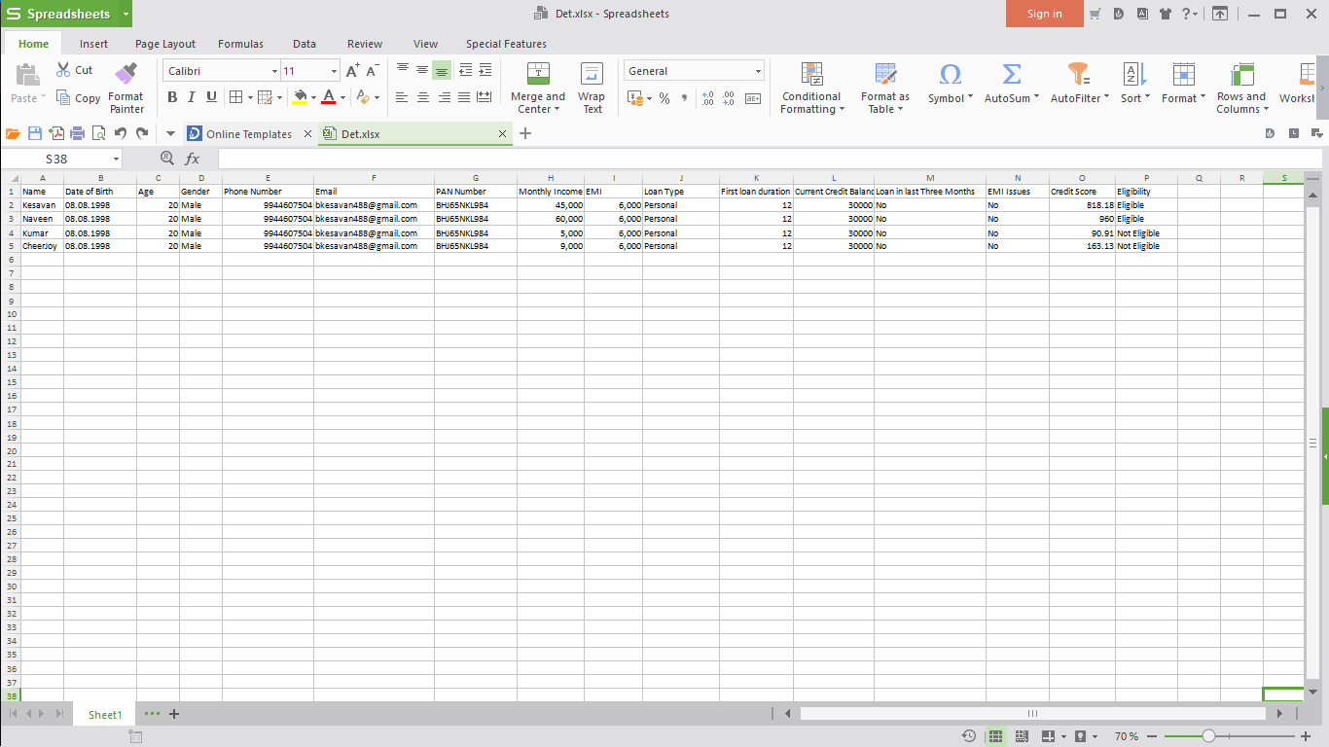

**Fig 4.4 credit score updated file**

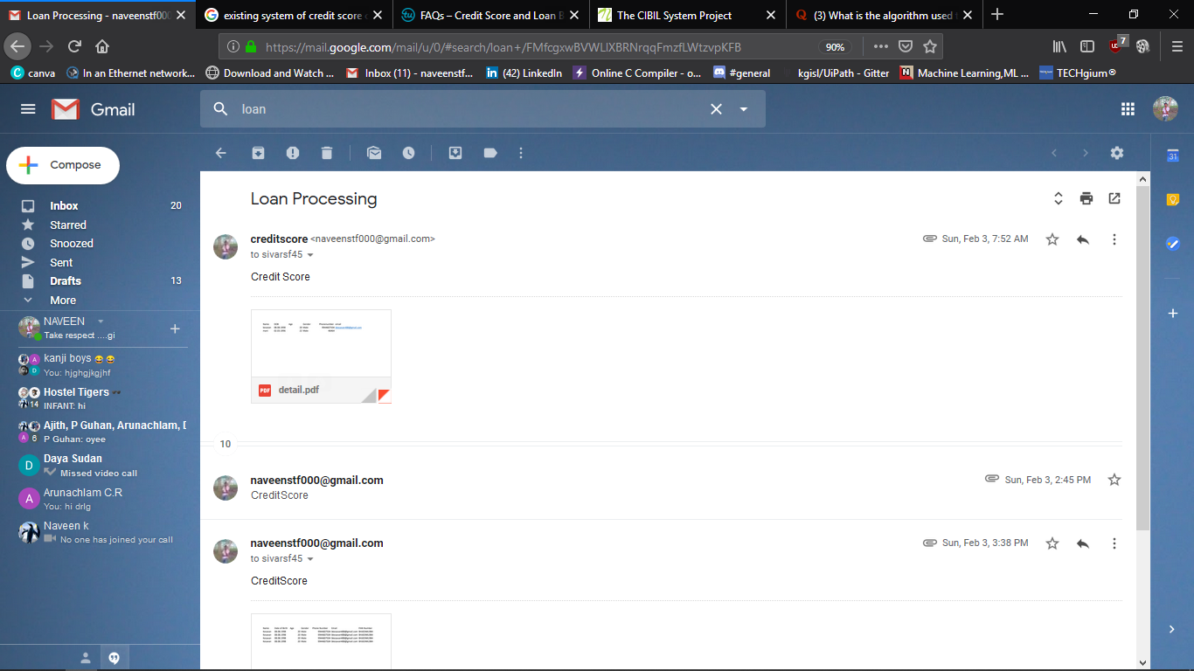

**Fig 4.5 Approval status of customer.**

**CHAPTER 5**

**CONCLUSION AND FUTURE SCOPE**

1. **1.CONCLUSION**

The loan approval process has been automated using UiPath studio work flows. The Details are stored in excel workbook and credit score details if a person is eligible are not. Then, the email automation and the notification is sent to customers thereby simplify using the loan approval process to customers for a loan.

1. **REFERENCES**

[1] Dr. Elvin MEKA “Loan Management and Its Ex Ante & Ex Post Role in the Lending process” Feb (2010)

[2] Begoña Gutiérrez-Nieto, Carlos Serrano-Cinca, Juan Camón-Cala “A Credit Score System for Socially Responsible Lending” Nov(2011)

[3] Ansen Mathew “Credit Scoring Using Logistic Regression” May(2017)

[4] Manu Chandra “Acquistion credit scoring model” Apr(2015)

**Web References:**

[5] UiPath Community Edition

<https://forum.uipath.com/>

[5] Software Robots in UiPath

<https://www.uipath.com/product/robots>

[6] UiPath Workflows

<https://forum.uipath.com/t/about-the-ideas-contest/29770>